**NAME**

**REG NUMBER**

**3D POINT ANALYSIS**

**INTRODUCTION**

**Literature reviews**

The discussions made on this paper are based on the different studies, research and finds from a collection of documents under the file document and repository found at ModelNet4. According to Charles et al (2017) 3D voxel grids are the resultant of irregular data formation and help researchers transform such data into regular models. However, this process leads to irregular data rendering. Further to this paper on 3D classification and segmentations, a design for fro a special type of network was discovered that could consume point clouds in the various networks.

Further the study tries to establish some of the deep learning tier architectures that have the capability to reason on 3D geometric data variables on point cloud meshes. In their study, it was established that deep neural networks could consume point clouds. The theoretical network that they established PointNet was directly capable of consuming point clouds. Finally, this network was capable of consuming most of the approaches needed to perform the object classifications, part and semantic segmentation. One of the advantages of this approach model is the ability to group points and then a label over these points, such a process will necessitate the data processing at laser cloud level. On the contrary single points may be unstable if the point cloud density is non uniform.

According to Martin (2019) graph structured data can be used as a method to understanding some of the problems as predictions are also made over the same. To diffusions across the patterns edge specify weights are applied on the labels and towards the e edges of the boxes. According to this particular study, data can naturally exist in regular and irregular domains and as such, such data can be structured as graphs in many scenarios .His study on “edge conditioned filters in convolutional neural networks on graphs” concluded that for each input sample edge conditioned convolution filters weights can be conditioned on edge labels systematically be used for inputs.

Whereas in another study done by Christian et al (2019) on scalable surface reconstruction from point clouds with extreme scale and density diversity indicated that it was possible to vastly create a 3D surface derived from a multi scale view stereo point. In their conclusions it was arrived that it was possible to perform surface re construction based on hybrid approach amidst volumetric and Delaunay surface reconstruction.

**Dataset description:**

The datasets obtained from these studies were obtained from a wide variety of globally availed images. Some we based on online search engine queries. The data passed through quality care and checks by human skill force after which specific models were applied on the data set, to get what was and what was not part of the CAD elements. The dataset used in this project is collection of a variety of CDA models used in the training of the deep network in the 3D learning learning model that follow the 8/20 rule, i.e., 80% set for training and 20% for testing the variables.

Further, the CAD models provided are in object file format and in the dataset is a collection of some of the latest datasets provided buy N. Sedagaat that focus on the Orientations-boosted Voxel Nets for 3D object Recognition. However among these modes is one intersecting model depicted by Shuran Song on the representation of 3D shape nets for deep representation of for volumetric shapes whereby recent advanced changes of the 2,5D depth sensors, intelligent systems need to be developed to choose he best view in to obtain extra observation from other viewpoints. The dataset in the same sis supplied on the model Net framework and includes some of the best and most common CAD files.

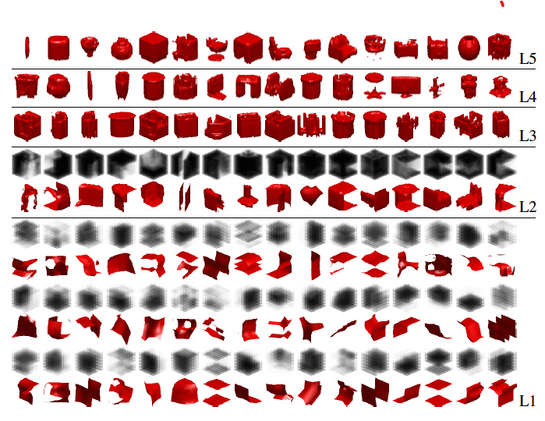

One of such frameworks that have been developed is gladly used is the Microsoft Kinect tool that is currently in use for deep object representation, built on the C# language, a variety of datasets both pertained and test together with the images are supplied on this model and used to show how just deep object sensing and modelling of 3D images can work

The datasets obtained from the 3D point cloud analyses were used in trying to model a sample 3D point cloud. The source code for this section is attached:

**REFERENCES**

Qi, C. R., Su, H., Mo, K., & Guibas, L. J. (2017). Pointnet: Deep learning on point sets for 3d classification and segmentation. In Proceedings of the IEEE conference on computer vision and pattern recognition (pp. 652-660)

Mostegel, C., Prettenthaler, R., Fraundorfer, F., & Bischof, H. (2017). Scalable surface reconstruction from point clouds with extreme scale and density diversity. In Proceedings of the IEEE Conference on Computer Vision and Pattern Recognition (pp. 904-913).

Wu, Z., Song, S., Khosla, A., Yu, F., Zhang, L., Tang, X., & Xiao, J. (2015). 3d shapenets: A deep representation for volumetric shapes. In Proceedings of the IEEE conference on computer vision and pattern recognition (pp. 1912-1920).